Practical-5

Task

1. Using the “use” command to connect to a new database.

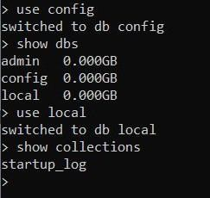

1. Create one collection



1. 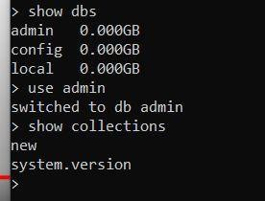Apply the commands to show your database and collection both.

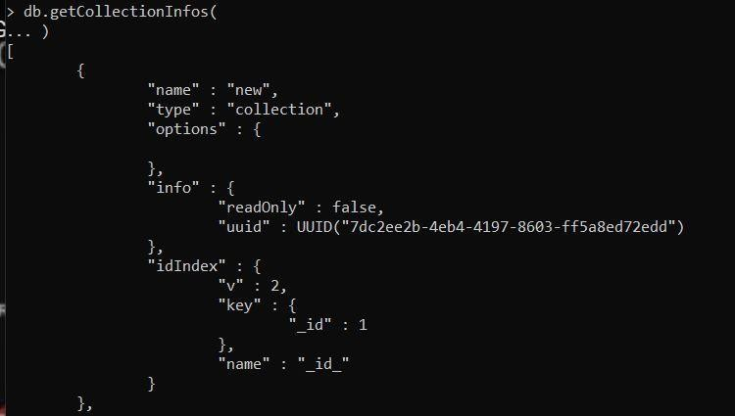

1. Insert minimum 4 documents into your database.

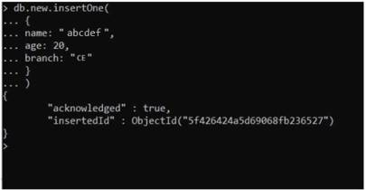

1. Use find() to list them out.

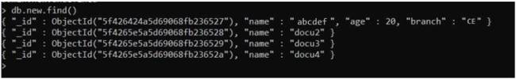

Task

Create a database name “petshop” and into it create collection name “pets” containing the documents having the name of the pets and species of them given below:

Pets name : Mikey, DaveyBungooligan, SuzyB , Mikey, Terrence, Philomena Jones Species : Gerbil,Piranha,Cat,Hotdog,Sausagedog,Cat.

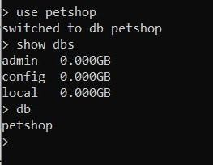

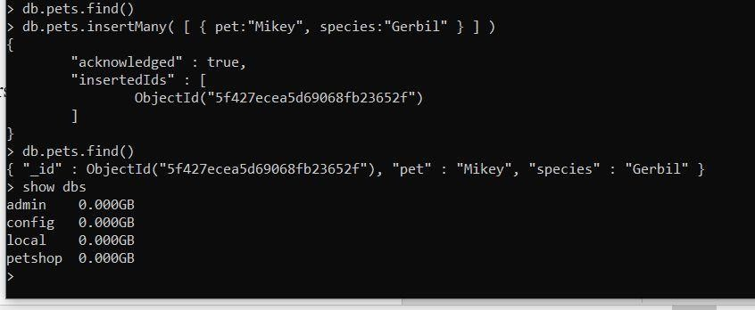

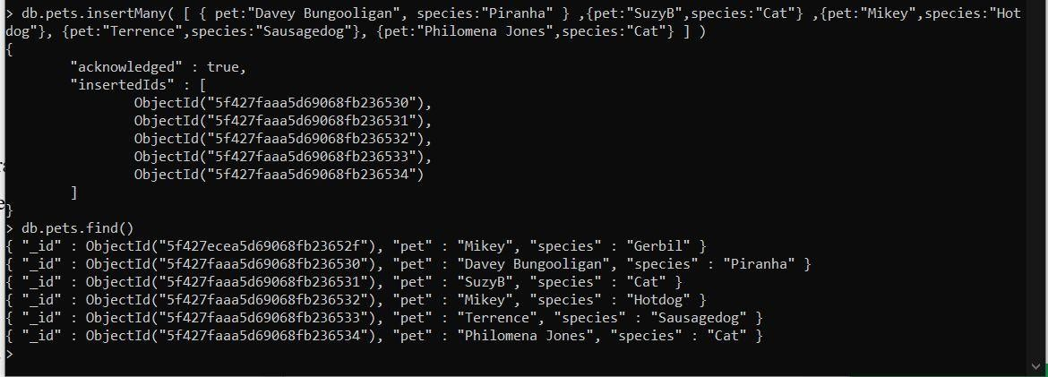

Perform Queries to get following Results:

* 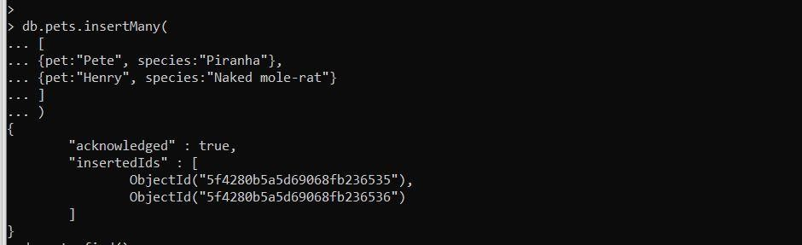Add another piranha called Pete, and a naked mole rat called Henry.
* Use find to list all the pets. Find the ID of Mikey the Gerbil.

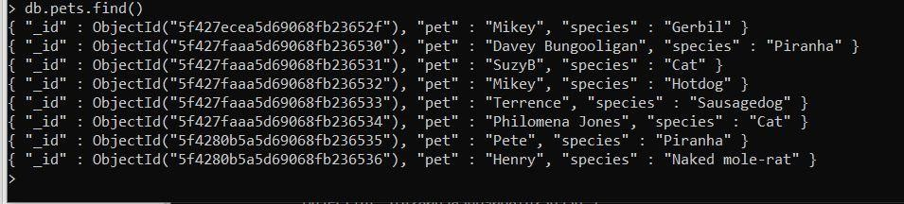

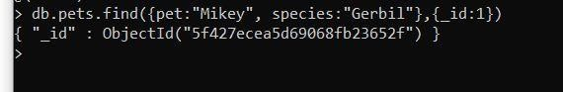

* Use find to find Mikey by id



* 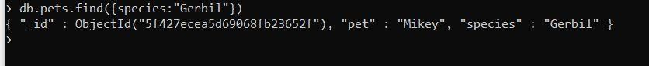Use find to find all the Gerbils.
* Find all the creatures named Mikey.

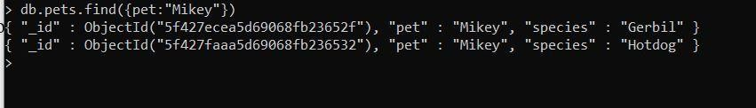

* 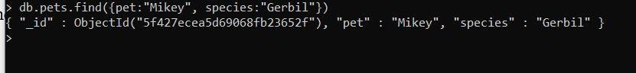Find all the creatures named Mikey who are Gerbils.
* Find all the creatures with the string "dog" in their species.

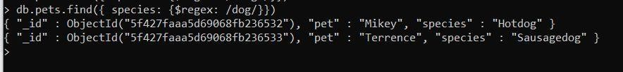

TASK:

Create a “Hospital” Database and collection name “Patient” with the format of document given below of it.

{

"firstname":"ronaldo", "lastname":"crist", "age":30,

"history" :[

{"disease":"cold", treatment":..123...

{......}

]

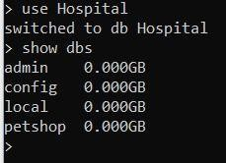}

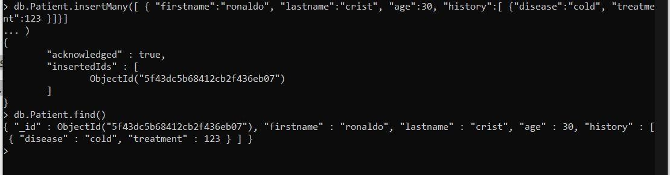

Perform the following:

1. 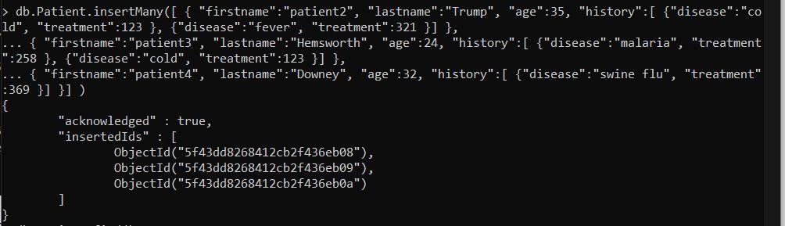Insert 3 Patient record with at least 1 history entry per patient

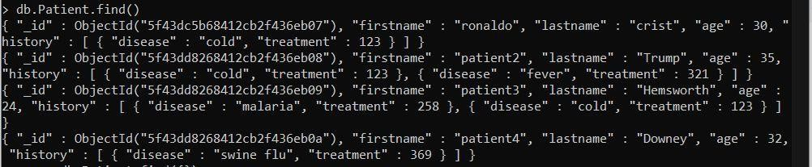

1. Update 1 data of 1 Patient with new age, name and History Entry.

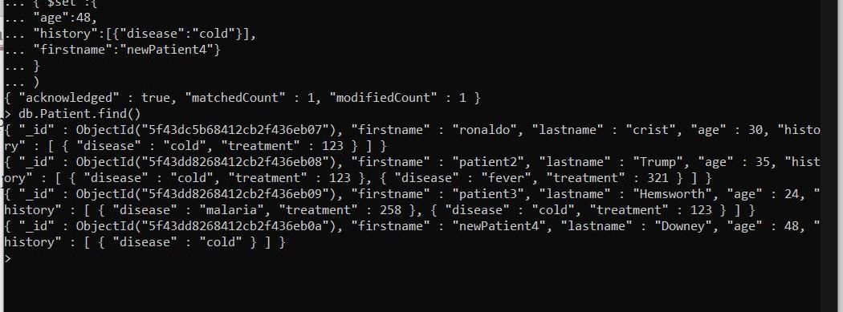

1. 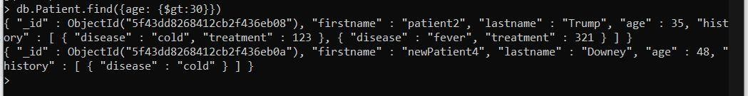Find all patients who are older than 30 (Or Value of your choice you made in your data.)
2. Delete all patients who have a cold as a disease. (Or According your Data )

